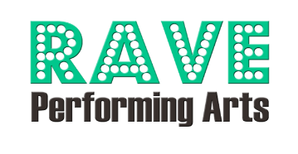

Personal Ad Form
RAVE Revue 2025 Program Book
Due by April 14, 2025
Step 1 Personal Information
Dancer’s Name: | Class:
Person of Contact: | Phone:
Email: | Date:

Step 2 Please circle the ad size and price you are purchasing. Early bird pricing is available through picture day, April 5, 2025 (20% discount).
Ad Size | Ad Specifications | Price | SPECIAL - Early Bird Price
Booster | Text Only – 25 words Max; 4” x 1” | $30 | $25
Business Card | Business Card and/or Message Only; 4” x 2” | $42 | $35
¼ page (portrait) | Limit 1 photo; 3.75” x 5” | $60 | $50
½ page (landscape) | Limit 2 photos; 7.5” x 5” | $90 | $75
Full page (portrait) | Limit 4 photos; 7.5” x 10” | $120 | $100
Inside Front Cover | 8.5” x 11” | $300 | $250
Inside Back Cover | 8.5” x 11” | $300 | $250

Step 3 If you choose a photo that was taken on Picture Day, we encourage you to purchase that photo through the photographer, DK Hebert Photography. Send photo(s) or DK photo number and text for the ad to our program designer, Mrs. Chelsea, at chelseawademorgan@gmail.com.
Additional Questions? Contact: Email - raveperformingarts@gmail.com
-------------------------------------------------------------------------------------------------------------------------------------------
For Office Use Only:
Payment Type: Credit Card __________ PORTAL _________ Check # ___________ Cash __________
Total Amount: ________ Date Received __________________ Initials of Staff Member _____________

