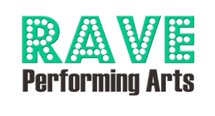
Business Advertisement - How To Guide
2026 RAVE Revue
Program Designer Email: chelseawademorgan@gmail.com
RAVE Performing Arts Company, LLC
13517 Hooper Rd, Baton Rouge, LA 70818
www.raveperformingartsco.com

It’s easy to get your ad into our program. Follow these 3 easy steps!
Due by April 13
1. Fill out the form
Fill out the Business Advertisement form and return to RAVE Performing Arts.

Email us images and/or text
Option 1 - Send us your ad: Email us your ad. Make sure it’s the same size as the ad you purchased, or we may have to do some cropping! PDF only.
Option 2 - We can design your ad: Email us the text you would like your ad to say as well as any other images/graphics you’d like included (high-resolution files accepted only). You must own the rights to those images/graphics if they are submitted to us. Don’t forget to send your business logo (preferably png file).
Dimensions: | ¼ page ad | ½ page ad | full page ad
 | 3.75”x5” (portrait)  Limit 1 photo | 7.5”x5” (landscape)  Limit 2 photos | 7.5”x10” (portrait)  Limit 4 photos

You’re almost done!
- Make sure the completed form and money have been submitted (check, cash, or credit card accepted).
- Each ad must have its own separate form.
- If your ad has been processed, you will receive a verification email. Please contact us if you do not receive this email.
- Early bird pricing valid through March 21, 2026.

