RAVE Performing Arts Company, LLC
Dress Code Guide

Tiny Dancers (Parent & Me)
1. Pastel or black solid leotards with an additional or attached ballet skirt (not a tutu)
2. Footed tights in ballet pink color
3. Ballet Shoes: pink leather, full-soled ballet shoes

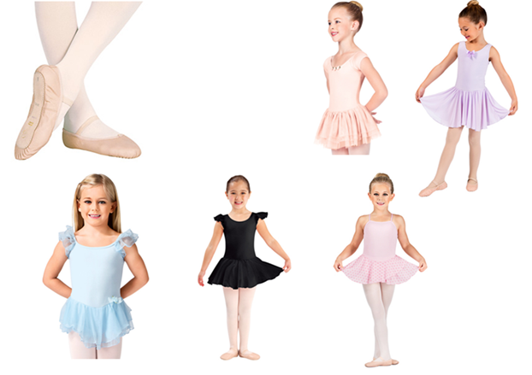
Little Movers & Primary
1. Pastel or black solid leotards with an additional or attached ballet skirt (not a tutu)
2. Footed tights in ballet pink color
3. Ballet Shoes: pink leather, full-soled ballet shoes
4. Tap Shoes: black, patent-leather tap shoes with a hard sole (We ask for laces to be replaced with elastics or snaps for quick change)

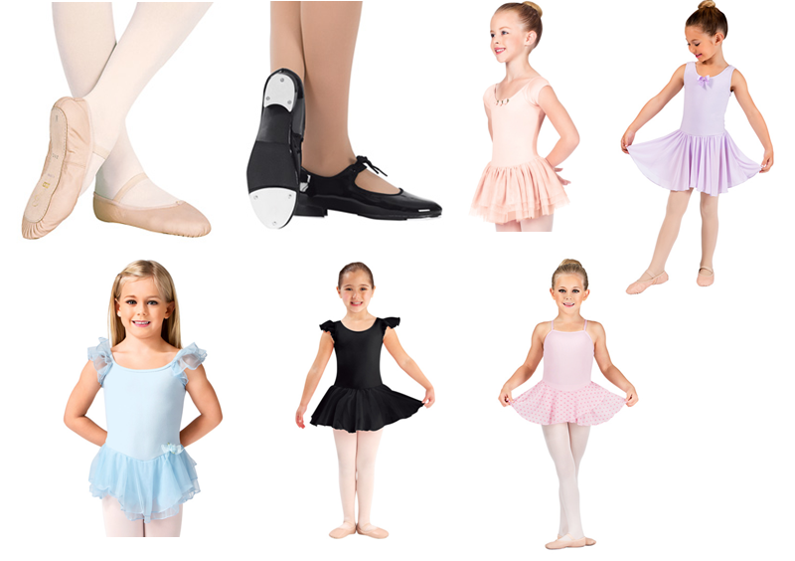

Secondary
1. Pastel or solid black leotard with additional or attached ballet skirt (not a tutu)
2. Footed tights in ballet pink color
3. Ballet Shoes: pink leather, full-soled ballet shoes
4. Tap Shoes: Tan leather tap shoes with a hard sole that buckle instead of lace up
5. Jazz Shoes: Tan, slip-on, jazz shoes with elastic arch
6. Male Students: Fitted athletic shirt and pants, with boy's full sole ballet shoes, black full sole lace up rhythm taps, black, slip-on, low-rise jazz shoes with elastic arch

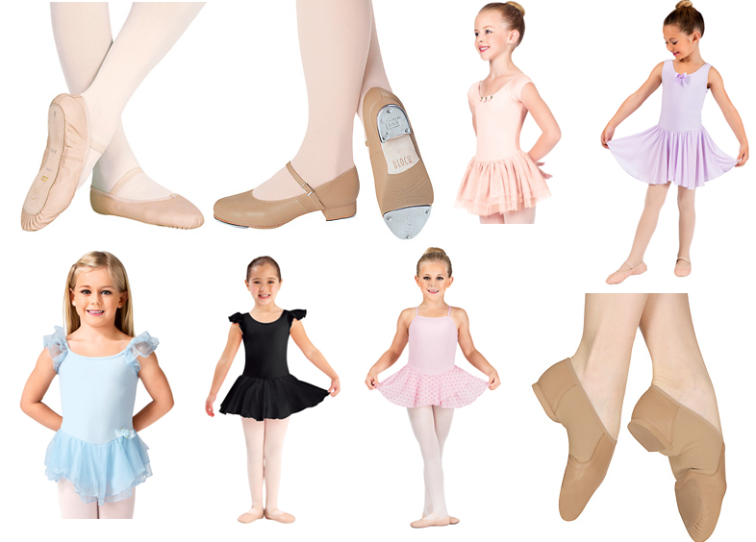

Level 1
Ballet:
1. Any color solid leotard
2. Pink convertible tights
3. Optional, tie-on ballet skirt (no other cover ups allowed)
4. Shoes: pink canvas or leather, split-sole ballet flats with cross straps or single strap
5. Male Students: Fitted athletic shirt and pants, with men's full or split sole ballet shoes
Jazz:
1. Leotard or fitted dance top of any color with leggings, jazz pants, or fitted dance shorts (Tan tights worn with dance shorts.)
2. Male Students: Fitted athletic shirt and pants
3. Tan, slip-on jazz shoes with elastic arch
Tap:
1. Leotard or fitted dance top of any color with leggings, jazz pants, or fitted dance shorts (Tan tights worn with dance shorts.)
2. Tan, leather lace up rhythm taps with hard sole.
Hip Hop:
1. Any color, comfortable, loose-fitting dancewear.
2. Flat sole sneakers
Contemporary:
1. Leotard or fitted dance top of any color with leggings, jazz pants, or fitted dance shorts (Tan tights worn with dance shorts.)
2. Shoes: Dance paws, pirouettes, or socks are allowed. One can even go barefoot if they choose.

Level 1 Shoes Guide
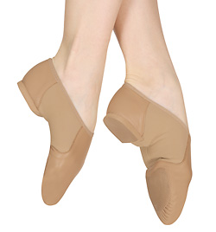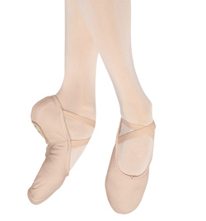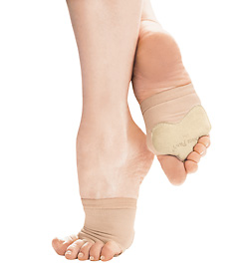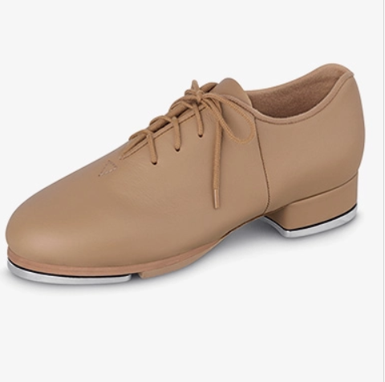

Levels 2, 3 and 4
Ballet:
1. Any color solid leotard
2. Pink convertible tights
3. Optional, tie-on ballet skirt (no other cover ups allowed)
4. Shoes: pink canvas, split-sole ballet flats with cross straps
5. Point Shoes: Must attend a fitting with a qualified faculty member (only for Pointe Class students)
6. Male Students: Fitted athletic shirt and pants, with men's full or split sole ballet shoes

Jazz:
1. Leotard or fitted dance top of any color with leggings, jazz pants, or fitted dance shorts (Tan tights worn with dance shorts.)
2. Male Students: Fitted athletic shirt and pants
3. Tan, slip-on jazz shoes with elastic arch or pirouettes
Tap:
1. Leotard or fitted dance top of any color with leggings, jazz pants, or fitted dance shorts (Tan tights worn with dance shorts.)
2. Black, leather rhythm taps with hard sole.
Hip Hop:
1. Any color, comfortable, loose-fitting dancewear.
2. Flat sole sneakers. Socks recommended with sneakers.
Contemporary:
1. Leotard or fitted dance top of any color with leggings, jazz pants, or fitted dance shorts (Tan tights worn with dance shorts.)
2. Shoes: Dance paws, pirouettes, or socks are allowed. One can even go barefoot if they choose.

Musical Theatre
- Any form-fitting dance attire such as a leotard or dance top with dance shorts or leggings. Loose fitting shorts and tops such as t-shirts ARE NOT allowed.
2. Shoes: Jazz shoes (tan, slip-on jazz shoes with elastic arch)
3. Male Students, black slip-on, low-rise jazz shoes with elastic arch

Acro & Baton
- Any form-fitting dance attire such as a leotard or dance top with dance shorts or leggings. Loose fitting shorts and tops such as t-shirts ARE NOT allowed.
2. no shoes – students will be barefoot

NOTE:
Dancewear can be obtained through our studio's new merchandise store. Local dancewear stores that are recommended are Top Toe on O’Neal or Hannah’s Dancewear in Denham Springs

Levels 2, 3 and 4 Shoe Guide
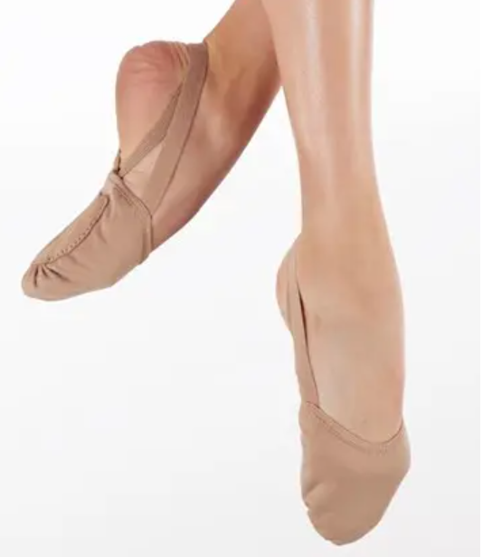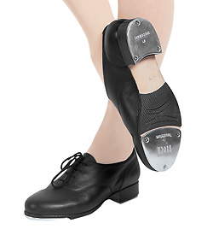

Advanced Tap Shoe Recommendations (but not required):
Capezio Roxy Tap, Block Jason Samuel Smith, Capezio K360, or Miller & Bens

