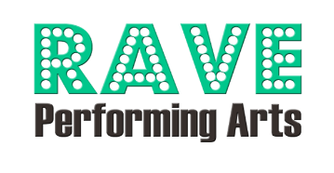

Business Ad Form
RAVE Revue 2025 Program Book
Due April 14, 2025
Step 1 Personal Information
Business Name:
Person of Contact: | Phone:
Email: | Date:

Step 2 Please circle the ad size and price you are purchasing. Early bird pricing is available through picture day, April 5, 2025 (20% discount).

Ad Size | Ad Specifications | Regular Price | Early Bird Price
Business Card | Business Card Only; 4” x 2” | $42 | $35
¼ page (portrait) | Limit 1 photo; 3.75” x 5” | $60 | $50
½ page (landscape) | Limit 2 photos; 7.5” x 5” | $90 | $75
Full page (portrait) | Limit 4 photos; 7.5” x 10” | $120 | $100
Inside Front Cover | 8.5” x 11” | $300 | $250
Inside Back Cover | 8.5” x 11” | $300 | $250

Additional Questions?
Contact: Email – raveperformingarts@gmail.com

-----------------------------------------------------------------------------------------------------------------------------
For Office Use Only:
Payment Type: Credit Card _____ PORTAL _____ Check # _________ Cash __________
Total Amount: ________ Date Received ____________ Initials of Staff Member___________

