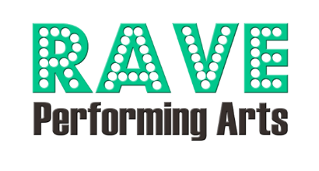

Personal Ad - How To Guide
2026 RAVE Revue
Program Designer Email: chelseawademorgan@gmail.com
It’s easy to get your ad into our program. Follow these 3 easy steps!
Due by April 13
1
. Fill out the form
Fill out the Program Book Advertisement Form and return to RAVE Performing Arts with payment (check, cash, credit card, or portal).
- Email us images and/or text
Option 1 - We can design your ad: Email us the DK Photo Number and text you would like your ad. Please put the dancer's name in the subject line. If you decide to send any other images/graphics you’d like included (high-resolution files accepted only), you must own the rights to those images/graphics.
Option 2 - Email us your ad: Make sure it's the same size as the ad you purchased, or we may have to do some cropping! Please put dancer’s name in the subject line of the email. PDF only!
¼ page ad | ½ page ad | full page ad
3.75”x5” (portrait)  Limit 1 photo | 7.5”x5” (landscape)  Limit 2 photos | 7.5”x10” (portrait)  Limit 4 photos
Dimensions:
Don’t forget! If you include a photo that was taken on Picture Day, we encourage you to purchase that photo through the photographer, DK Hebert Photography.
- You’re almost done!
  - Make sure the completed form and money have been submitted.
  - Each ad must have its own separate form.
  - If your ad has been processed, you will receive a verification email. Please contact us if you do not receive this email.
  - Early bird pricing valid through March 21, 2026.

